**Best Practice of our college**

1. **Inclusive Excellence: Celebrating Diversity:-**

Unity in diversity- a concept that signifies the presence of unity and harmony among people despite their cultural, religious, ethnic or social differences. We emphasize that diversity rather than being cause of division, can be a source of strength, creativity, and innovation when people come together with mutual respect and understanding.

At Sagardighi Kamada Kinkar Smriti Mahavidyalaya, we take pride in our commitment to inclusivity and diversity. Puja can be a communal activity, reflecting the idea of unity in diversity, as people from different backgrounds come together to participate in these rituals and celebrations, fostering a sense of togetherness and shared spirituality. A shining example of this is our Muslim community's dedicated efforts to organize and celebrate Saraswati Puja, a significant festival honouring the Hindu goddess of knowledge and arts. On the other hand Hindu students whole heartedly participate in Eid celebrations, promoting cross-cultural understanding. Also we uphold a tradition of inclusivity and mutual respect. Our students and staff from different faiths come together to celebrate each other's festivals, fostering a sense of community and social cohesion.

Best Practices:

**Interfaith Dialogue:** Encouraging mutual respect and understanding among different faiths.

**Cultural Exchange:** Showcasing the richness of diverse traditions and customs.

**Community Engagement:** Fostering a sense of belonging among all students and staff.

**Respectful Coexistence:** Embracing differences and promoting harmony.

**Post-Celebration Reflections:** Students from both communities come together to share their experiences, strengthening bonds and fostering empathy.

This exceptional initiative demonstrates our institution’s:

- Dedication to inclusivity and diversity

- Commitment to breaking down cultural and religious barriers

- Spirit of mutual respect and understanding

We continue to strive for excellence in creating a harmonious environment where everyone feels valued and respected.

1. **Commitment to Women's Safety: Our Best Practices:-**

It’s commitment and practice to achieve any faith than it’s maintained. At Sagardighi K.K.S Mahavidyalaya , we take pride in our commitment to creating a safe and secure environment for all students, particularly women. Our consistent track record of:

* Over 60% female student enrolment every year
* More than 65% of female candidates appearing for final exams

demonstrate our dedication to fostering a trustworthy and supportive atmosphere.

Key Best Practices:

* **Zero Tolerance Policy:** Strict action against any form of harassment or misconduct with girl students.

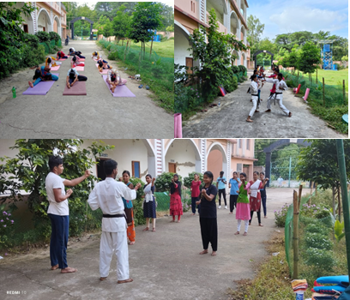

* **Women's Cell:** A dedicated platform for reporting concerns and seeking help.
* **CCTV Surveillance:** Strategically installed cameras ensuring constant monitoring.

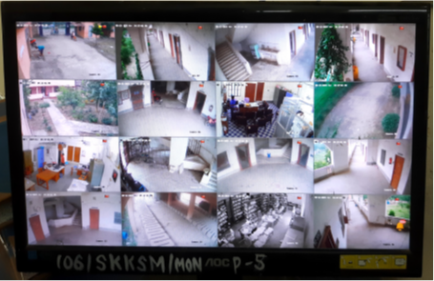

* **Sensitization Programs:** Regular discussion and awareness campaigns promoting gender equality.
* Separate girls’ common room to spend their free time with their friends.

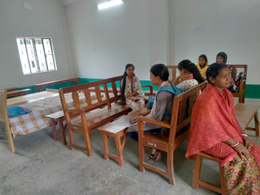

* **Emergency Response System:** Quick response mechanisms in place for immediate assistance in any kind of health issue.

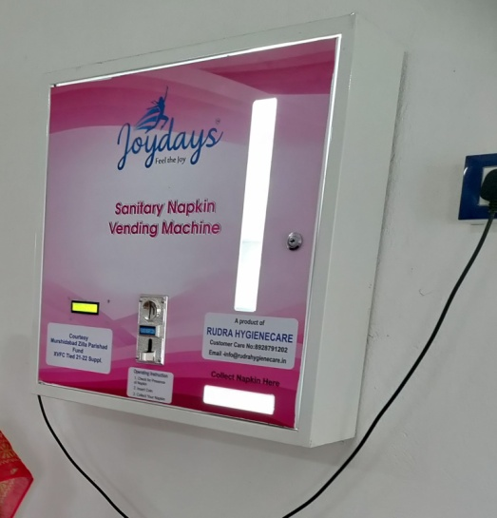

**Our Promise:**

We continue to uphold our commitment to women's safety, ensuring a nurturing environment for all students to thrive. Also, we committed to keep the faith of society and parents on us.

Notably, our college has an impeccable record of:-

* + Zero incidents of ragging
  + Zero cases of women harassment

|  |  |
| --- | --- |
| Registered Candidate | Appeared Candidate at Final Examination |
|  |  |
|  |  |
|  |  |
|  |  |
|  |  |
|  |  |